Motives Organization Doc:

-Introduction:
In this experiment, we are trying to solve the murder case of Captain Cornball. There are many suspects involved in this incident. The suspects include Theresa Tymes, Fred Fleckstone, Glen Glendora, Sam Stubs, and Norma Nanny. After doing research, we discovered that all the suspects are connected somehow through their family tree, which we think involves another suspect; Thomas Sandstone.

-Motives:
>Susan was married to Steve but Thomas Sandstone(Captain
Cornball) was having the affair with Susan
>Sam was engaged to Peebles in which Thomas killed and Sam was
not happy with it.
>Sam Stubs AND Norma might have worked together since the
finger print we found was Norma’s
>Thomas Sandstone “played around” with many of the suspects
families (Sam’s mother and Norma’s Aunt; Nina)

-Family Ties:

~Thomas Sandstone: Son of Thomas Mustard and June Basil.
He has two siblings, Kathy and Dominic. Thomas and June had two children, Peebles and Fred. June was the daughter of Joe Granite and Sarah Sands. Thomas kills Peebles and Joan (sister in law to Thomas). Thomas’ sister, Kathy, had Theresa with Jerry.

~Theresa Tymes: Daughter of June Granite (daughter of Joe Granite and Sarah Sand) and Thomas Sandstone (Son of Thomas Mustard and June Basil). Fred was engaged to Theresa Thyme, but they happen to be cousins without realizing it. They are cousins because Theresa’s mother, Kathy, is Thomas Sandstone’s sister.

~Fred Fleckstone: Son of June Granite (daughter of Joe Granite and Sarah Sand) and Thomas Sandstone. Had a sister named Peebles. Thomas Sandstone killed his sister and her Aunt Joan (Sister of June Granite). He changed his last name to Fleckstone from embarrassment. Now engaged with Theresa Thyme (who are awkwardly cousins as explained in Theresa’s Family Ties).

~Glen Glendora: Adopted at 6 months old by the Glendora Family. His original father he knows is Thomas Sandstone and his mother Susan Butts (daughter of Jimmy Butts and Rita). His half brother is Sam Stubs and his half sister is Sarah (their parents are Susan Butts and Steve Stubs. Susan had an affair with Thomas Sandstone (which is the reason why Glen Glendora exists in the first place) and set to adoption when he was born(probably so Steve or anyone else wouldn’t find out about the affair). Glen is now deeply in love with Norma Nanny.

~Sam Stubs: He is the son of Steve Stubs and Susan Butts. Steve had Huntington’s disease. Sam’s half brother is Glen Glendora. As Steve was starting to take a turn down the road of death, Sarah Butts had an affair with Thomas Sandstone. They ended up having a child (male) that Thomas decided to take to the adoption agency the day he was born. Susan Stubs, Sam’s mom, died 15 years after Steve did of Huntington’s disease. Sam was then engaged to Peebles Sandstone who got murdered. He has lately been seen with Norma Nanny.

~Norma Nanny: Greg Nanny and Kathy had Nina and Nancy. Nina was having an affair with Thomas Sandstone (Captain Cornball) at the age of 19. Nadia was their child and died at the age of 3 . After this Nina suffered depression and is institutionalized with no desire for dad . Nancy married Sam Stubs uncle (Tony) and they had Norma. Tony died when Norma was three. Norma took her moms maiden name Nanny. They later found that Tony had Huntingtons disease. Norma Nanny is in a love triangle with Glen Glendora loving her while she wants Fred Fleckstone.

~Captain Cornball: “Unknown”. Recently got out of jail. We think he is Thomas Sandstone because he said he changed his name, had many children, and had many lovers (which is everything Thomas Sandstone had).

-Blood Types/Syndromes/Diseases:

Name | Blood Type | Chromo-  somes | Marfan’s | Hunting-  ton’s
~Theresa Tymes | A-type | Down  Syndrome | No | No
~Fred Fleckstone | O-type | XXY | Yes | No
~Glen  Glendora | A-type | XY | No | No
~Sam Stubs | O-type | XYY | Yes | Yes
~Norma Nanny | A-type | XXX | No | Yes
~Captain  Cornball | O-type | XYY | No | No

*Extra Stuff:Origin of Blood & Disease w/ DNA Sequence*
~Fred Fleckstone:
> Tall, slender man
> Double-jointed
> DNA Sequence: GATTCCCAACGGG
>DNA fingerprint: B, Y
~Theresa Tymes:
> Kathy Mustard had O-type blood & Jerry Tymes had A-type blood
(Parents of Theresa Tymes)
> The Mustard family was all O-type blood, but Jerry’s parents both
had AB-type blood
> No information on incidences of her family having Marfans or
Huntington’s disease.
> DNA Sequence: GATTCCCAACGG
> DNA Fingerprint: R, B
~Sam Stubs:
> Susan Stubs had A-type blood
> Her spouse Steve had B-type blood
> DNA Sequence: GATTCCCGACGG
>DNA fingerprint: R, Y, B

~Glen Glendora:
> Adopted, but knows his parents were Susan Stubs with had
blood and Thomas Sandstone O-type blood
> Glen’s mom died of Huntington’s disease.
> Glen is an achondroplastic dwarf.
> DNA Sequence: GATTCCGAAGGG
>DNA fingerprint: Y

~Norma Nanny:
> Greg Nanny had flat feet, poor eyesight and a low I.Q. Also has
A-type blood and his wife, Kathy, has B-type. Their two children were Nina(AB-type) and Nancy(O-type).
> Tony died of Huntington's disease.
> DNA Sequence: GATTCCCAACGG
>DNA fingerprint: B, Y

~Captain Cornball (Thomas Sandstone):
> We know Thomas Sandstone is Captain Cornball for many reasons. First it was reported that Thomas Sandstone changed his name and we suspect he changed it to Captain Cornball. Second he has slept with many women much like Captain Cornball. Also we don’t know much about his life besides the facts that he likes women and to sleep with them (which is why he had many children).
> DNA Sequence: GATTCCGAACGG
>DNA fingerprint: R, Y, B

-What do we think? (Evidence)
-Norma Nanny and Thomas Sandstone killed Captain Cornball.
-Captain Cornball is Thomas Sandstone (obviously).
-Sam Stubs and Norma Nanny may have worked together since both of their DNA was found at the crime scene.
The two have also been seen together, but there is no record of them knowing each other prior to the incident.
-Sam was engaged to Peebles, who was killed by Thomas Sandstone.
-Norma Nanny has an attraction to Fred Fleckstone, brother and son of Peebles and June Sandstone, both killed by Thomas Sandstone.

Crime Scene Photos:

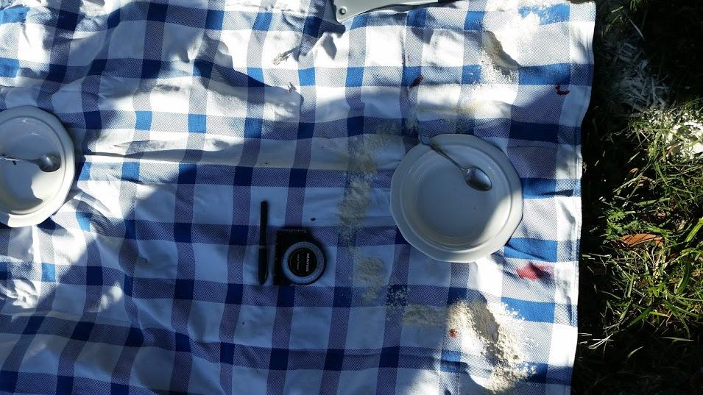
Overhead view of actual crime scene

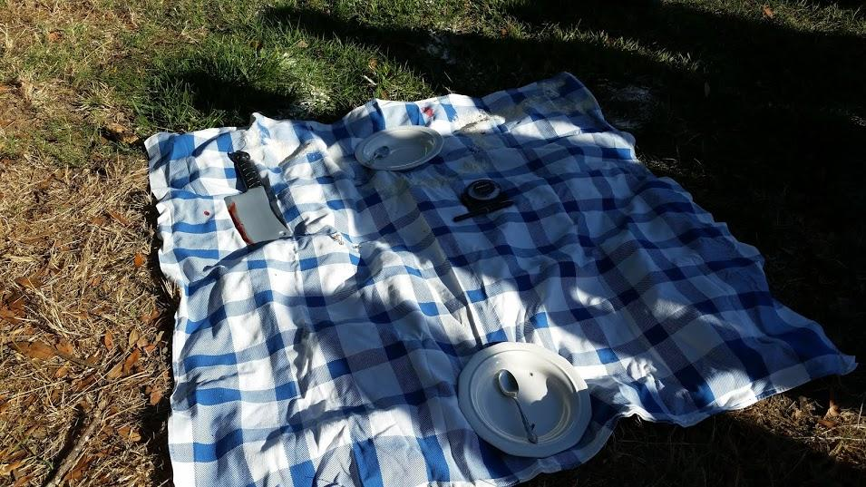
Side overhead view of crime scene
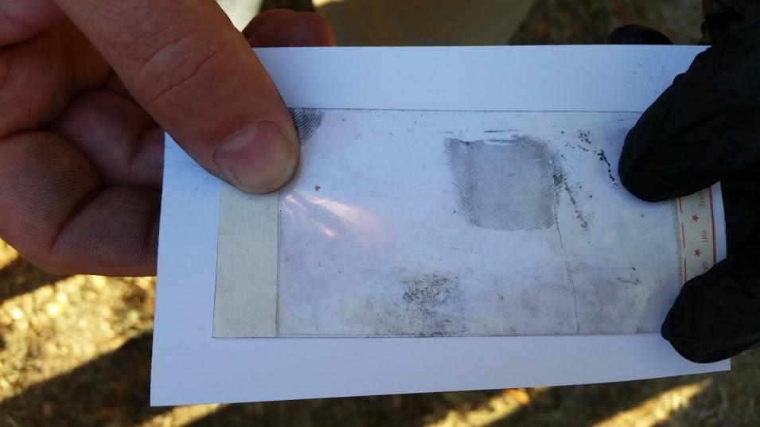
Fingerprint collected at the crime scene

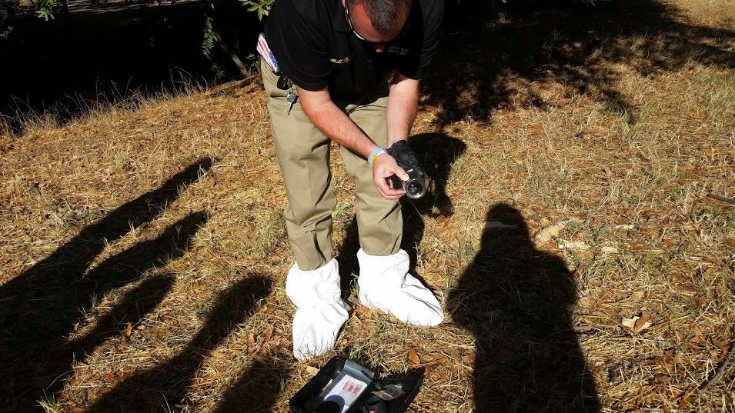
North Bay Security worker Matt Davis collecting DNA at the crime scene with a cotton swab

Another overhead view of the crime scene with more shadow

